In stack First In Last Out that means first entered element pop in last.

In this assignment, sequences is the pop return values.

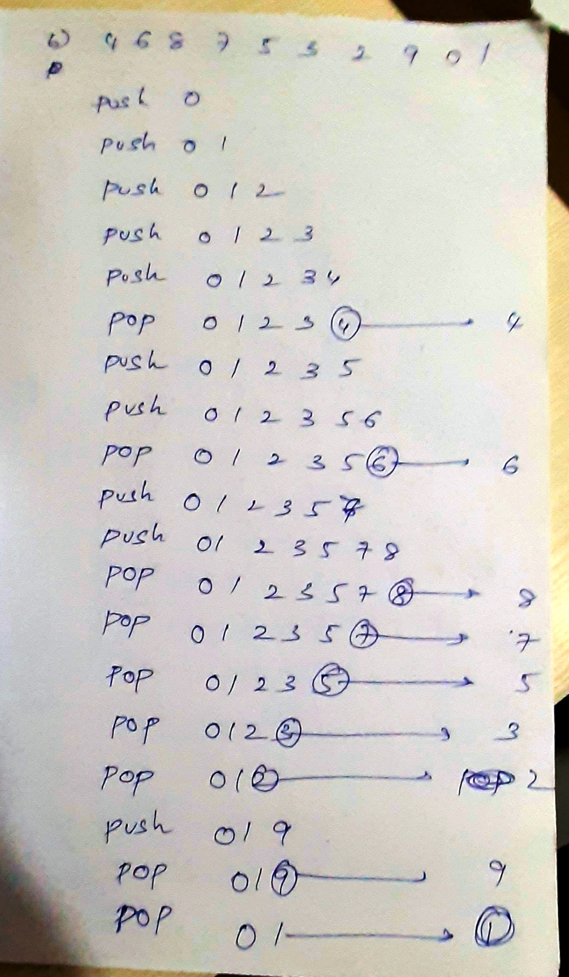

In the above picture I explained the case b

Like this f and g also could not occur.